**Evidence for Project Unit**

Your name here

Your Cohort

Date here

**P- 1 Github Contributors page**

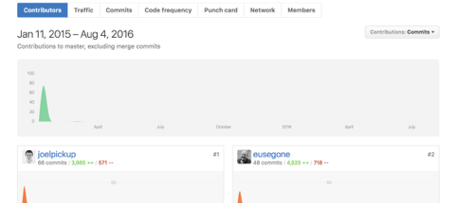

**P- 2 Project Brief**

Write your project brief here for the group project, if you cannot remember ask one of the instructors or try to write one yourself based on the project you have created.

**P-3 Use of Trello**

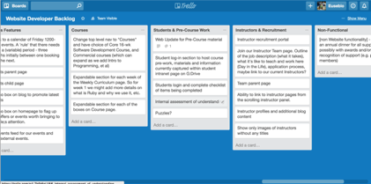

**P-4 Acceptance Criteria**

|  |  |  |
| --- | --- | --- |
| **Acceptance Criteria** | **Expected Result/Output** | **Pass / Fail** |
| A user is able to search for a particular film by a keyword or title | Films that match the keyword or title are displayed in a table | PASS |
| A user is able to add films to a list | Films in users movie database appear in a drop down menu and once selected are added to the list record and displayed on the list page | PASS |
| A user can see a list of reviews that they have written | Film reviews are displayed when the review page is visited by clicking the review page link | PASS |
| A user can save a movie from the displayed search results | Film is saved to database when the save button is clicked and displayed on the movies page when opened | PASS |

**P-5 User sitemap**

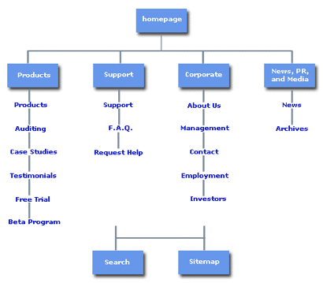

**P-6 Wireframes designs**

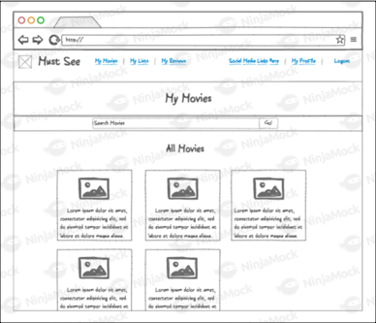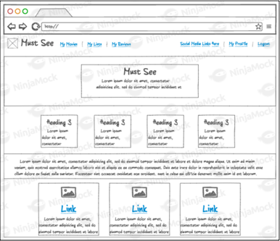

**P-7 System interactions diagrams**

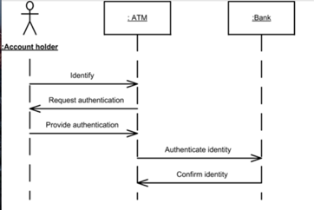

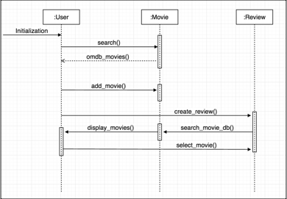

**P-8 Two Object Diagrams**

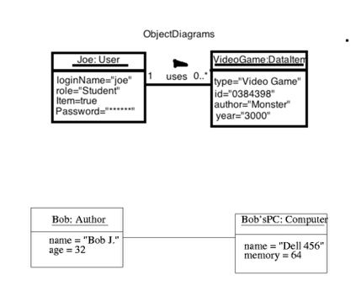

**P- 9 D.T.- a Choice of two algorithms (find the algorithms on a program you might have written, show the code you have used. )**

**On this example please take a screenshot and write what it is doing and why you decided to use it.**

**A - Search Algorithm- For one of the projects I carried out I had to find items in a warehouse, by bays and rows. The best way to do this was to use a search algorithm, where the items had an ID. I had passed the ID into the function and iterated through the items checking the ID I was looking for.**

**B- Delete Algorithm - In the same project I had to delete items from the warehouse. The delete algorithm allowed me to go and find the item by ID and delete it from the array of items, in each bay.**

**P - 10 Example of Pseudocode**

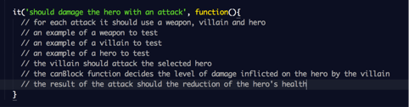

**P - 11 Github link to one of your projects**

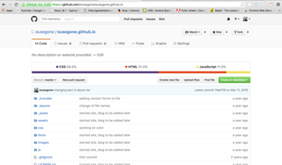

**P - 12 Screenshot of your planning and the different stages of development to show changes.**

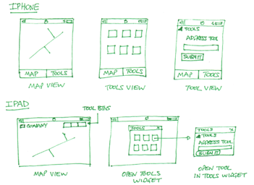

**P - 13 User input**

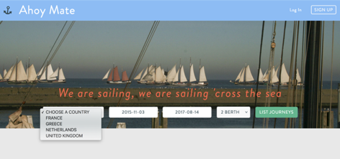

**Make sure you show the input being added.**

**P - 14 Interaction with data persistence**

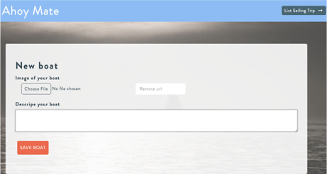

**P - 15 User output result**

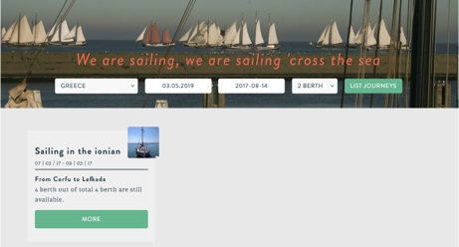

**P - 16 Bug tracking report showing the errors diagnosed and corrected.**

|  |  |  |  |
| --- | --- | --- | --- |
|  |  |  |  |
| **User must be able to add a trip** | **Failed** | **Saving a user, using the ID to assign a trip** | **Passed** |
| **Trip has a starting and end date** |  |  | **Passed** |
| **Trip date cannot be made for dates passed** | **Failed** | **Added validations to stop creation of trips with past dates** | **Passed** |
| **Trip can only have a number of available spaces** | **Failed** | **Set a number of spaces available per trip.** | **Passed** |

**P -17 Testing your program**

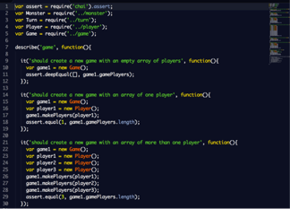

**Show the test code, the test not passing…..and then the test fixed.**

